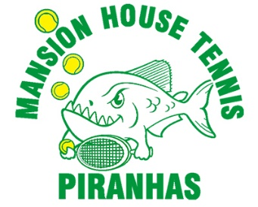

ADULT TENNIS CLASSES

REGISTRATION

When: Thursdays (June 21,28 and July 5,12,19,26 and August 2, 9)

Cost: $120 for 8 weeks per class

Where: Mansion House Tennis Courts

Who: All Levels Welcome (racquets provided if needed)

Stroke of the Week: 6:00 p.m. – 7:00 p.m. $120
Practice and hone a different stroke each week. All levels welcome.

Cardio Tennis: 7:00 p.m. – 8:00 p.m. $120
Fun and fast paced dead and live ball drills – Designed to raise your heart rate and give you a great workout! (Will hit a minimum of 100 balls and burn 1,000 calories!) All levels welcome.

NAME: _________________________________________________________________MHC Member #_______

ADDRESS: ___________________________________________________________________________________________

PH1: ____________________________ PH2: __________________________

EMAIL:________________________________________________________

PLEASE SELECT: QTY TOTAL($)

☐ Stroke of the Week ________ ________
☐ Cardio Tennis ________ ________

Please make check payable to: MANSION HOUSE CLUB TOTAL: $

